ANALYSIS OF BOARD BILLS 126, 127, AND 128
(UNHOUSED BILL OF RIGHTS AND ASSOCIATED BILLS)

President of the Board of Alderman Megan Green and her allies are pushing hard for a transformation of the City of St. Louis’ approach to homelessness. Unfortunately, as described in more detail in Exhibit A hereto (Matt O’Leary’s Business Journal Op-Ed), this proposed giant step backwards will result in:
- A flood of homeless individuals from outside the City coming into the City to live on the streets and take advantage of new resources that enable that existence.
- Fewer resources being available to help City residents escape homelessness through the provision of housing, given those resources will be redirected to non-City residents and long-term shelter.
- The evisceration of the rights of City neighborhood to determine which facilities that serve the homeless are allowed to locate in those neighborhoods.
- The abandonment of the evidence-based, best practices strategy for decreasing homelessness, Housing First, in favor of the long-discredited long-term shelter model.
- Removal of St. Louis’ police force as a tool available to neighborhoods to mitigate the disastrous consequences of large numbers of unhoused individuals living on the City’s streets.

In order to accomplish this giant step backwards, Board Bills 126, 127 and 128 include provisions, described in detail in Exhibit B hereto, that:
- Amend the zoning code to allow homeless shelters to set up shop in every neighborhood of the City, with little if any input from these neighborhoods.
- Strip from the City Code geographic prohibitions on intentional encampments in almost every ward in the City, thereby allowing them throughout the City.
- Amend the Property Maintenance Code to eliminate the requirement that homeless shelters secure neighborhood consent via the plat and petition process before being granted an occupancy permit.
- Amend the Property Maintenance Code to remove the prohibition on homeless shelters (and similar uses) opening within 500 feet of a school.
- Decriminalize, for homeless and non-homeless individuals, the current crimes of aggressive panhandling and loitering.
- Repeal the ordinance making urinating and defecating in public a crime, as it relates to people who are homeless.
- Sets up a series of escalating criminal penalties levied on individual police officers if those officers infringe on any right of any person, homeless or not, to use a public space or exercise unfettered freedom of movement.
- Prohibit the City from clearing an unpermitted encampment unless it has shelter beds / housing options available that are acceptable to every resident at the encampment.
- Establishes the obligation on the City to set up “safe camping areas” throughout the City for individuals, City resident or not, who would rather camp outside in a neighborhood than take available shelter or housing. This includes imposing an obligation on the City to provide toilets, showers, waste collection, and security for such an encampment.

It is of crucial importance that the City’s neighborhoods unite to oppose these radical Board Bills and instead demand changes to the system that put an end to the practice of the surrounding counties refusing to provide services to their homeless citizens and instead dumping them in the City. The City has ample shelter, housing and other services for its population of homeless City residents, but not for the entire St. Louis region and other regions beyond. The solution to the continuing homelessness crisis is not to double down on strategies that grow homelessness and spread the problem throughout the City, but instead to focus City resources on City residents and force surrounding areas to take care of their homeless citizens.

EXHIBIT A

St. Louis homeless bills would perpetuate failed policies | Opinion
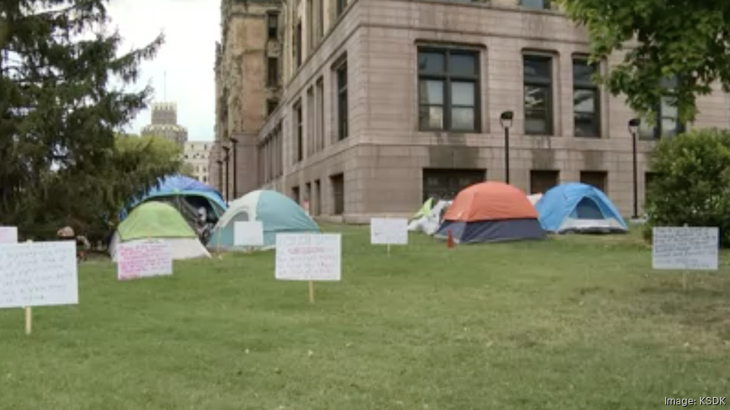

By Matt O'Leary – member of Citizens for a Greater Downtown St. Louis
Oct 1, 2023

St. Louis Alderwoman Alisha Sonnier is to file two bills, one that removes prohibitions on new homeless shelters across the city and an “Unhoused Bill of Rights” that guarantees the rights of the unhoused to live in public spaces and rights-of-way, supported by a network of publicly supported shelters and encampments.
The problem is these guarantees of the rights of the homeless, most not from the city of St. Louis, trample the rights of city neighborhoods to regulate neighborhood uses; undermine the city's adopted model for ending homelessness — housing first; and will generate a flood of homelessness into the city.
The central question is what the city's “goals” should be related to the unhoused, given our status as a high-poverty municipality with 10% of regional population? The answer is the city should direct its scarce resources to:
- Providing housing, not shelter
- To the city's homeless residents
- With the goal of dramatically decreasing the population of unhoused individuals in the city
Sonnier’s bills satisfy none of these goals.
The bills reject housing first, the national best practices model, which focuses on “housing” as the solution to homelessness.
Instead, they favor long-term “shelter” as the solution to the unhoused population already living on the city's streets. The theory is if the city can support these individuals with shelter and encampments, then over time they can be coaxed from their lives on the streets. The problem is long-term shelter, a model that was discredited decades ago, doesn’t reduce street homelessness. It grows it.
Most of those living on the streets, like those at the current City Hall encampment, are “chronically homeless.” These individuals, often fighting long-term demons, are very mobile via platforms like Megabus. When long-term shelter is prioritized as part of an ecosystem that supports life on the streets, the result is large numbers of chronically homeless individuals migrating to communities that offer these supports. This is precisely what happened when, pursuant to its 2005 10 Year Plan to End Chronic Homelessness, the city targeted resources at safe havens, shelter and close to 500 permanent supportive housing units to eradicate chronic homelessness. By 2015, the new units/beds were full and there were more chronically homeless individuals on the city's streets than 10 years before.
Also, these bills have no requirement that city resources be directed to city residents in need, instead establishing facilities and services available to anyone who is unhoused, regardless of where from. The City had a residency requirement through 2012, but it was discontinued largely because it was unenforced by service providers who preferred large, regional facilities located in the city. The creation of an Unhoused Bill of Rights in the city, but nowhere else in the region, will make permanent the regional practice of dumping the unhoused in the city.
The Rev. Philip Mangano, the federal homelessness czar from 2001-2009, recounted to me a conversation with the St. Louis county executive. Mangano begged him to accept $10 million in annual federal homelessness funding to better serve St. Louis County’s large, unhoused population. The county executive refused, transparently because he was content with exporting county homeless residents to the city. Taking funds would require developing additional services in the county, which would be political suicide.
The city's neighborhoods, already working to address a public safety crisis, can’t afford the passage of these bills that will dramatically increase the number of chronically homeless individuals from all over the region and beyond living on city streets, and the massive negative externalities caused, without offering city neighborhoods rights to object or recourse when this experiment fails.

EXHIBIT B

DETAILED DESCRIPTION OF PROBLEMATIC PROVISIONS OF BOARD BILLS 126, 127 AND 128

BOARD BILL 128 - AMENDING THE ZONING CODE

Section Four

Section Four of Board Bill 128 adds a new Zoning section for Special Residential Uses.

- Code Section 26.75.030 (Use Regulations for Special Residential Uses): This provides that all Special Residential Uses (including boarding houses, group homes, halfway houses, rooming houses, shelters (congregate and single-room occupancy), transitional housing, and support services), which includes homeless shelters, are allowed as conditional uses in every zoning area of the City, with one exception (shelters with 8 or less sleeping accommodations are permitted uses in all zoning areas except A, B, J and K).

- Code Section 26.75.040 (Site Requirements for Special Residential Uses): While there are various requirements for Special Residential Uses, such as no rope lights around windows, none of them substantially address the impact of the Special Residential Uses on the surrounding community, other than there needs to be some off-street employee parking, the facility shall comply with the City’s noise ordinance, and the facility won’t become a public nuisance (a law rarely enforced by City government). Most of the problems associated with Special Residential Uses, particularly homeless shelters, that are of concern to neighborhoods happen outside the facility, not inside. These Board Bills largely ignore that reality.

Section Three

Section three of Board Bill 128 has specific additional negative impacts on I, J, K and L zoning areas.

- Code Sections 26.52.025 / 26.56.025 / 26.60.025 / 26.64.025: Alcohol and/or drug abuse treatment centers, group homes, halfway houses, social rehabilitation facilities, and transitional living facilities are removed as conditional uses in I, J, K, and L zoning areas and therefor become “permitted uses” with no restrictions or vehicle for neighborhood input at all. Moreover, these restrictions conflict with the provisions of 26.75.030.

BOARD BILL 127 - PLAT AND PETITION CHANGES UNDER THE PROPERTY MAINTENANCE CODE

Board Bill 127 repeals the prior Ordinance, 70798, that adopted the 2018 International Property Maintenance Code, and re-adopts the 2018 International Property Maintenance Code with new amendments. The most important and consequential amendments is summarized below.

- Section 903 (Plat and Petition): Board Bill 127 deletes section 903, thereby eliminating the Plat and Petition Requirement (requiring a majority of signatures in support from either property owners or registered voters within 500 feet of the facility) for any new boarding house, rooming house, dormitory, or Special Residential Use (including homeless shelters).

- Section 903 (Prohibition of Homeless Shelters by Schools): Board Bill 127 also eliminated the prohibition on such homeless shelters being located within 500 feet of an elementary or secondary school. It would thus allow homeless shelters, which often have significant numbers of registered sex offenders as clients, to locate immediately next to schools.

BOARD BILL 126 – EQUAL RIGHTS FOR THE UNHOUSED

Section Six, Section A2 of Board Bill 126 indicates the intent to alleviate the adverse effects and conditions caused by homelessness for “all individuals”, regardless of whether they live in or have any ties to the City. It is not clear 1) where the Board of Aldermen derives the authority to spend scarce City revenues on alleviating homelessness for “all individuals”, regardless of where from, when doing so consumes resources that could be directed to the City’s large unhoused population, or 2) why homeless individuals who are not from the City of St. Louis, but who migrated to the City after becoming homeless, should have rights that are superior to existing City residents who are not homeless.

Sections Repealing/Amending Existing City Laws that Protect Neighborhoods

Please note that several of the below laws are being repealed not just related to unhoused individuals, but to all persons in the City of St. Louis.

- Section One (Repealing Aggressive Panhandling Law): This repeals section 15.44 of the City Code related to Aggressive Panhandling, meaning this current ordinance violation would no longer be illegal, whether the person aggressively panhandling is unhoused or not (many non-homeless people aggressively panhandle).

- Section Two (Repealing Loitering Law): This repeals section 15.48.010 of the City Code which prohibits loitering. This does not just relate to homeless individuals, but removes loitering as a City crime for all persons.

- Section Four (Amending Law Prohibiting Public Urination/Defecation): This amends Ordinance 67075 which prohibits public urination and defecation, by excepting “(a)ny person who is unhoused and/or residing in an emergency shelter, transitional housing, or encampment”. This decriminalizes public urination and defecation for the unhoused even when done on private property (i.e. the yard of a single family home).

- Section Six, Section D(b) (Neighborhood Orders of Protection): This bars Neighborhood Orders of Protections that target behaviors associated with homelessness, including panhandling, gathering in large groups, and sleeping outside. This is not limited to unhoused individuals but applies to any behavior associated with homelessness committed by any person.

- Section Six, Section D(c): This bars City government or the police from enforcing laws (not just related to those who are unhoused):
- Restricting panhandling or begging.
- Restricting the use of public spaces for resting, sleeping or loitering (i.e. park curfews or laws against sleeping in parks).
- Prohibiting disturbing the peace.
- That prohibit private citizens from providing aid to those experiencing homelessness (i.e. requiring food safety or addressing littering).

Section Creating Individual Criminal Liability for Police Officers

  - Section Six, Section E (Enforcement): This sets up a series of escalating criminal penalties levied on individual police officers if, whether as part of their official duties or not, those officers:
- Infringe upon the right of any person (homeless or not) to use any public space, or even suggest that a person is legally obligated to move when no such obligation exists (i.e. trying to break up a fight by telling people to clear the area).
- Infringe upon the right of any person (homeless or not) to freedom of movement, by removing a peaceful person who is panhandling or suggesting they are legally obligated to move when no such obligation exists.

Sections Addressing Encampments

- Section Three (ARPA Funding): This repeals section 19 of Ordinance 71393 which prohibits Intentional Encampments in significant areas of most Aldermanic Wards of the City.

- Section Six, Section B (Clearing Encampments): This requires that before the City displaces homeless persons from an encampment, the City must give 30 days of notice to the persons living there and the Continuum of Care and members organizations. The Department of Human Services is charged with coordinating with services providers on finding shelter or housing for the displaced homeless persons. If there is insufficient shelter or housing available for all persons at the encampment (and not everyone is required to accept all types of shelter or housing), the City can’t close the encampment.

- Section Six, Section C (Safe Camping Areas): This requires that the City provide Safe Camping Areas for anyone who is not ready to enter a shelter environment, including using City funds to provide toilets, showers, waste collection, etc… Please note there is no indication of where these would go, what the process is to establish them, what rights the community these are located in would have, how many people could be in each one etc... Alderwoman Sonnier was quoted in the Post Dispatch as saying the bill “does not say where a safe camping zone would be… That would have to be a later legislative political discussion”.

